Sets

1. The sports offered at a retirement village are Golf (G), Tennis (T) and Swimming (S). The Venn diagram shows the numbers of people involved in each activity.
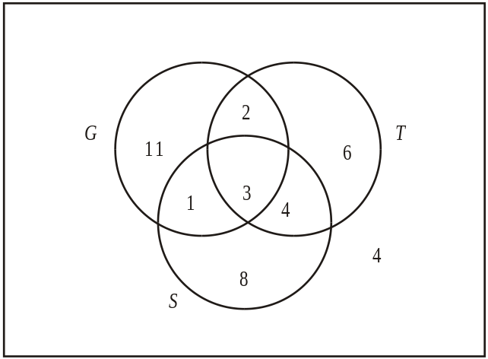
(a) How many people
(i) only play golf?
(ii) play both tennis and golf?
(iii) do not play golf?
(b) Shade the part of the Venn diagram that represents the set G’ ∩ S.
Working:
Answers:
(a) (i) ……………………………………..
(ii) …………………………………….
(iii) …………………………………….
(Total 4 marks)

2. In each of the Venn diagrams, shade the region indicated.
(a) A ∩ B
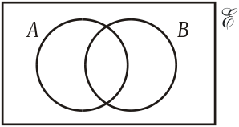
(b) The complement of (A ∩ B)
(c) The complement of (A ∪ B)
(d) A ∪ (B ∩ C)
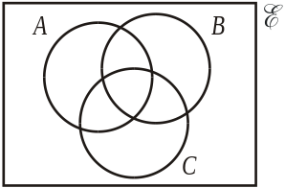
Working:
(Total 4 marks)

3. A group of 30 children are surveyed to find out which of the three sports cricket (C), basketball (B) or volleyball (V) they play. The results are as follows:
3 children do not play any of these sports
2 children play all three sports
6 play volleyball and basketball
3 play cricket and basketball
6 play cricket and volleyball
16 play basketball
12 play volleyball.
(a) Draw a Venn diagram to illustrate the relationship between the three sports played.
(1)
(b) On your Venn diagram indicate the number of children that belong to each region.
(3)

(c) How many children play only cricket?
(2)
(Total 6 marks)

4. 100 students were asked which television channel (MTV, CNN or BBC) they had watched the previous evening. The results are shown in the Venn diagram below.
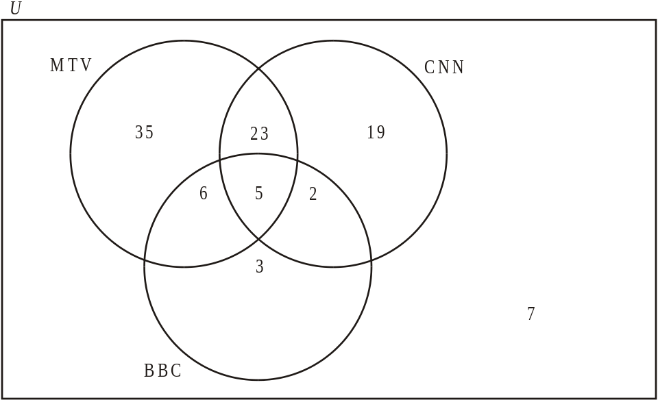
From the information in the Venn diagram, write down the number of students who watched
(a) both MTV and BBC;
(b) MTV or BBC;
(c) CNN and BBC but not MTV;
(d) MTV or CNN but not BBC.
(Total 4 marks)

Answers

Set Homework 1
1. (a) (i) 11 (A1) (C1)
(ii) 2 + 3 = 5 (A1) (C1)
(iii) 8 + 4 + 6 + 4 = 22 (A1) (C1)
(b)
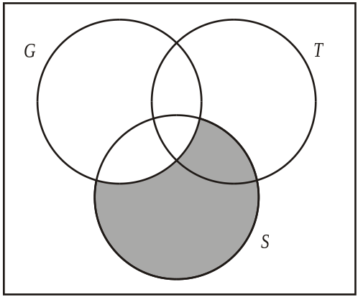 (A1) (C1)
[4]

2. (a) A ∩ B (A1)
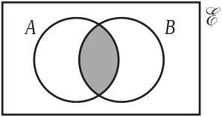
(b) The complement of (A ∩ B) (A1)
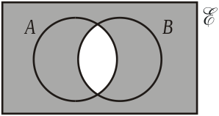
(c) The complement of (A ∪ B) (A1)
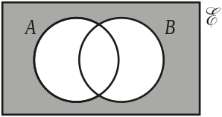

(d) A ∪ (B ∩ C) (A1)
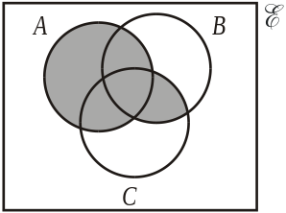
[4]

3. (a) (A1)
(b) (A3) 4
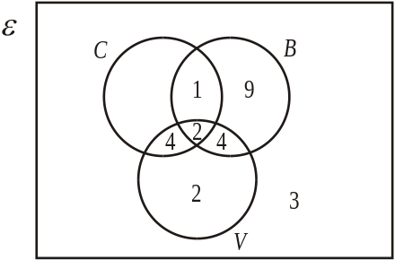
(c) 1 + 9 + 4 + 2 + 4 + 2 + 3 = 25 (M1)
n(C) = 30 – 25
= 5 (A1)
OR
n(C) = 5 (C2) 2
[6]
4. (a) n(MTV ∩ BBC) = 11 (A1)
(b) n(MTV ∪ BBC) = 74 (A1)
(c) n(CNN ∩ BBC ∩ MTV′) = 2 (A1)
(d) n(MTV ∪ CNN ∩ BBC′) = 77 (A1)
[4]

